Your submission for this project should be a Word document that includes the following screenshots, each labelled for the step that the screenshot represents:

1. Provide two screenshots. One screenshot should show that you successfully installed the flask-restful *library*. One screenshot should show that you successfully installed the flask-jwt-extended *library*.

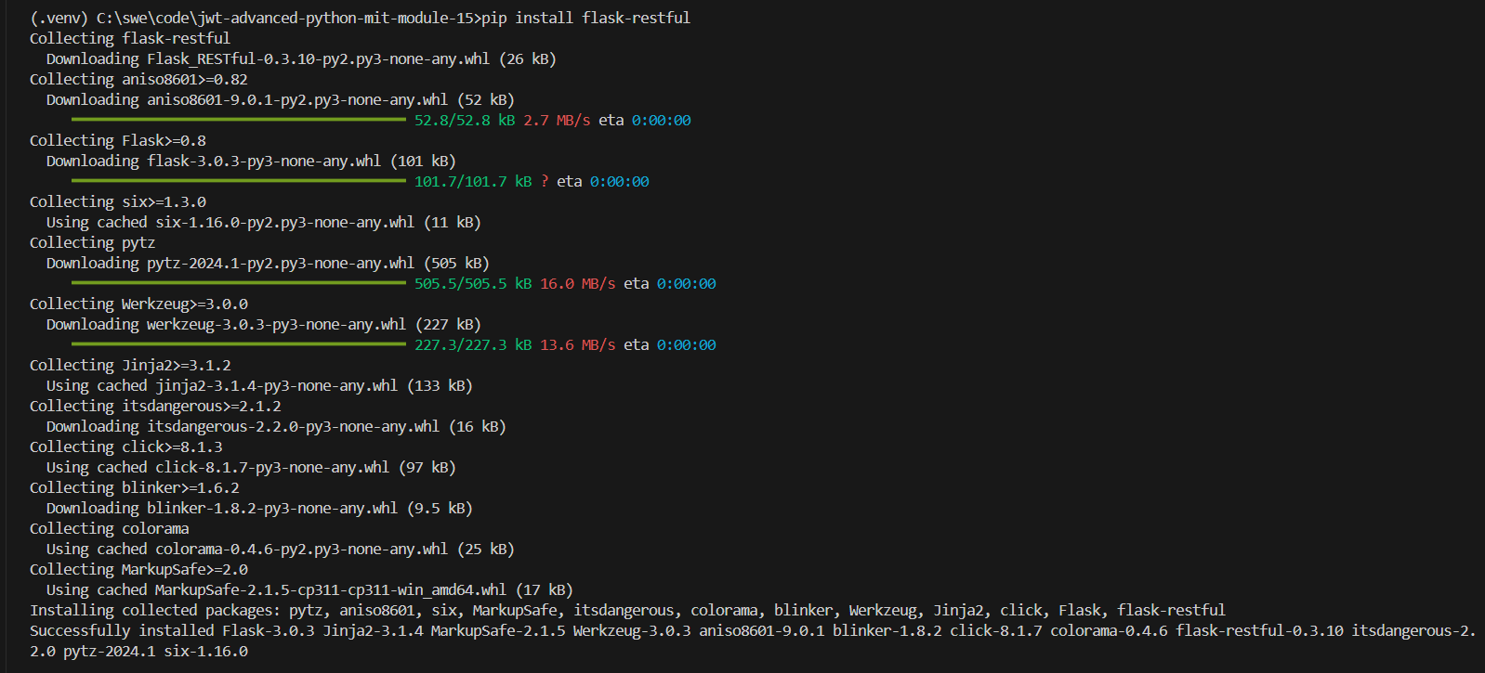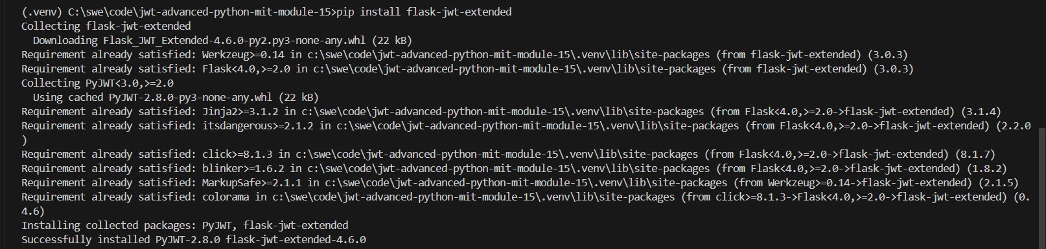

1. Provide a screenshot to show that you successfully opened the Project 15.1 folder using VS Code.

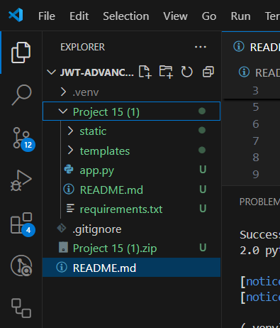

1. Provide a screenshot to show that you successfully added two more books to thebooks *list* in the app.py file.

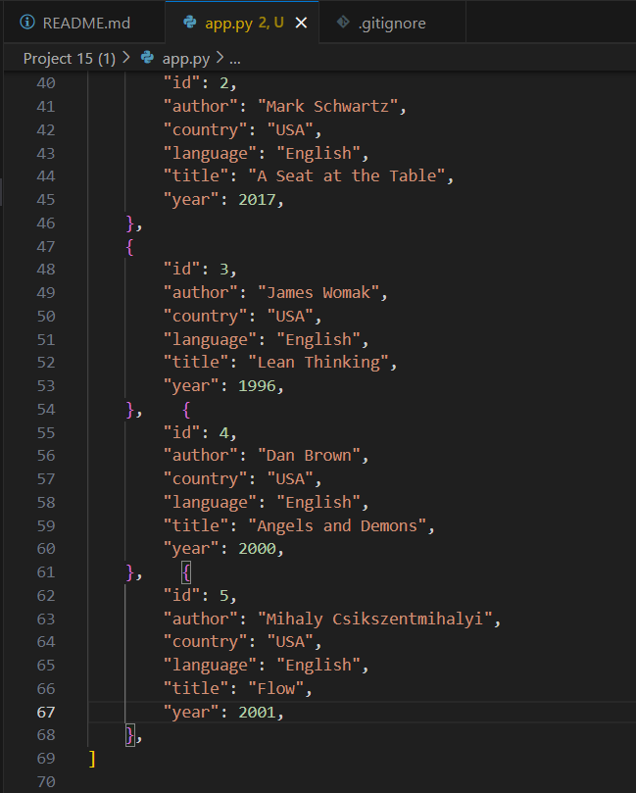

1. Provide two screenshots, one for each new cover image, to show that you successfully uploaded and opened the new cover images in the static folder using VS Code.

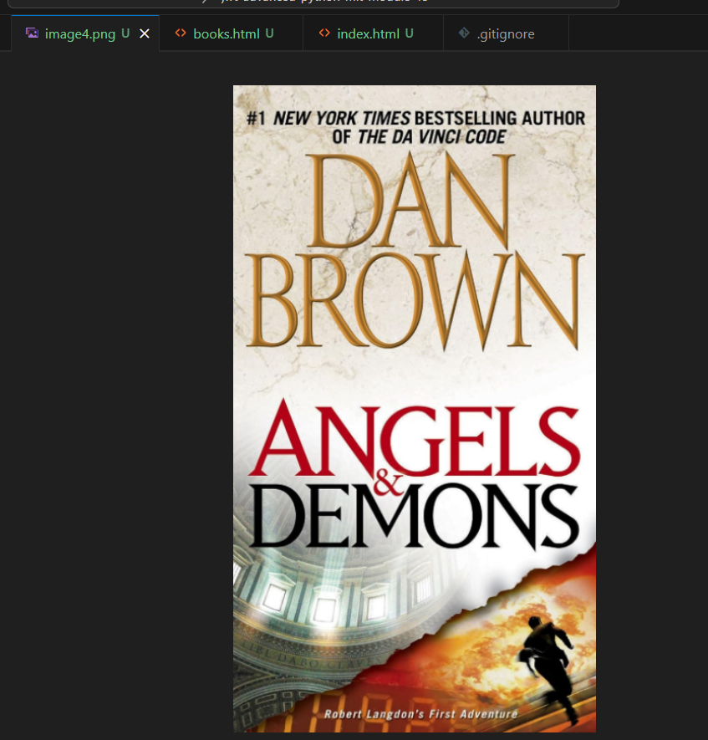

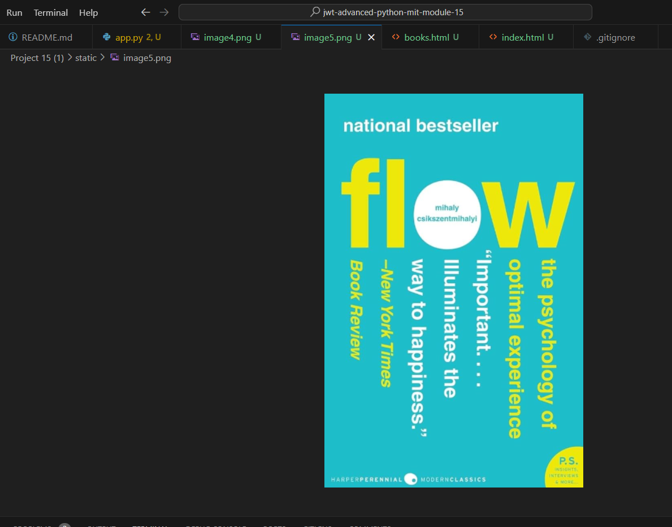

1. Provide a screenshot to show that you successfully added the correct html line of code in the the books.html file.

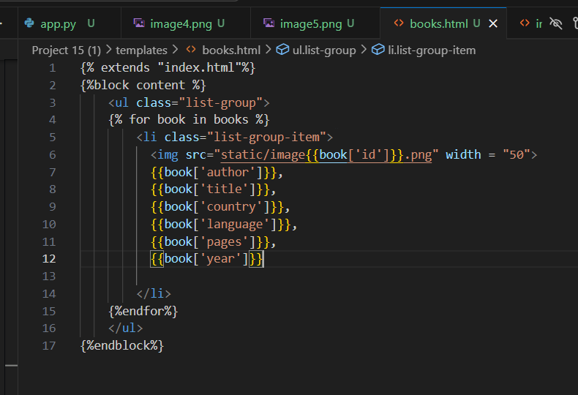

1. Provide a screenshot to show that you successfully added two new users, one with the role of admin and one with the role of reader, in the app.py file.

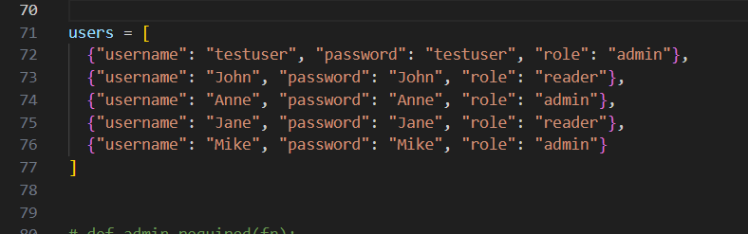

1. Provide a screenshot to show that you correctly defined the admin_required(fn) *function*.

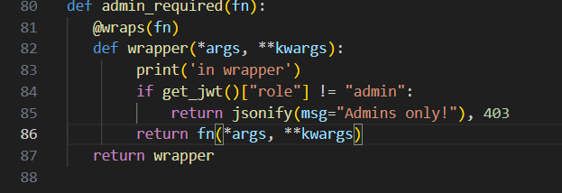

1. Provide a screenshot of your Terminal window to show that your code ran correctly and successfully connected to localhost:5000.

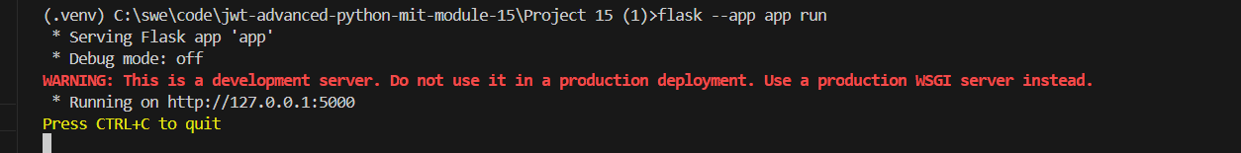

1. Provide a screenshot of your browser window to show that you correctly opened the page localhost:5000/.

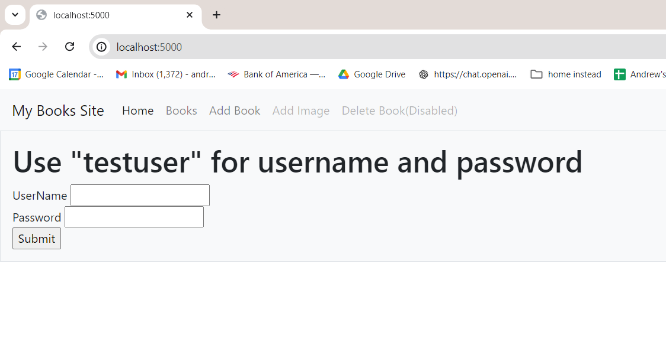

1. Provide a screenshot to show that you successfully logged in as an admin.

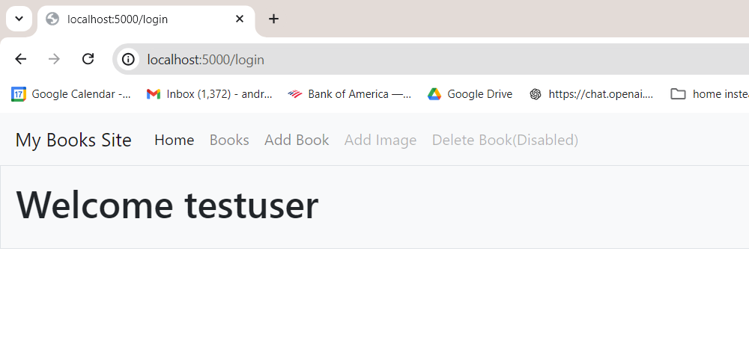

1. Provide a screenshot to show that you can successfully see all the books defined in the app.py file along with their correct cover images in the “Books” tab.

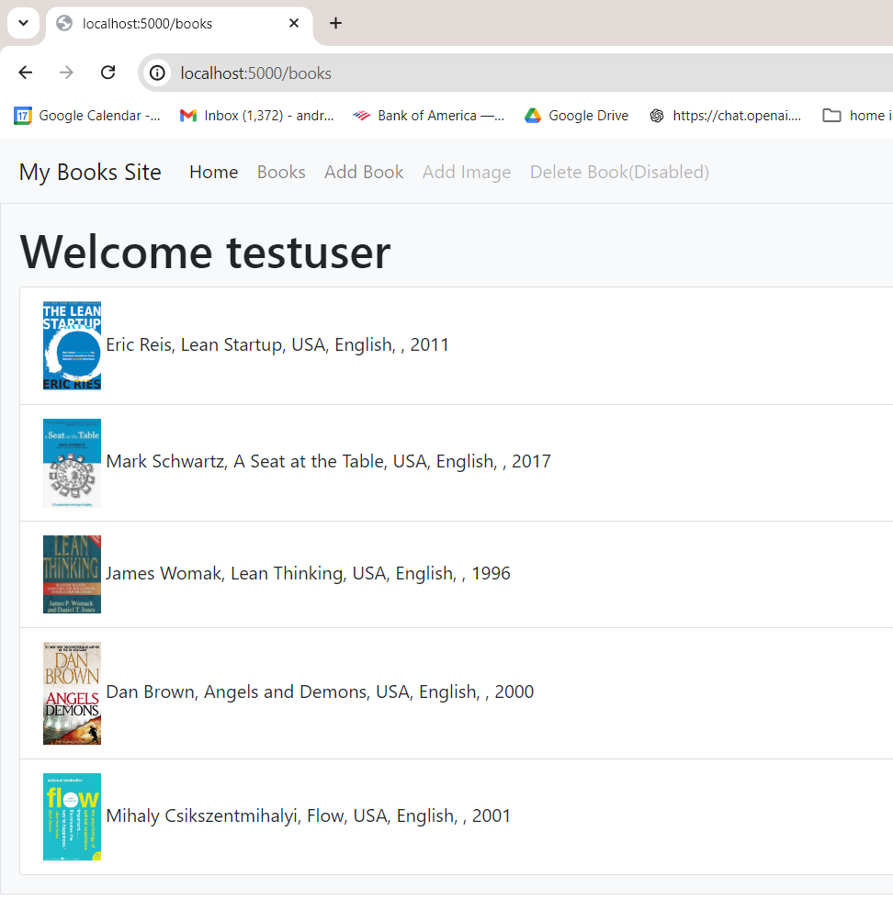

1. Provide a screenshot to show that you can add a book using the “Add Books” tab.

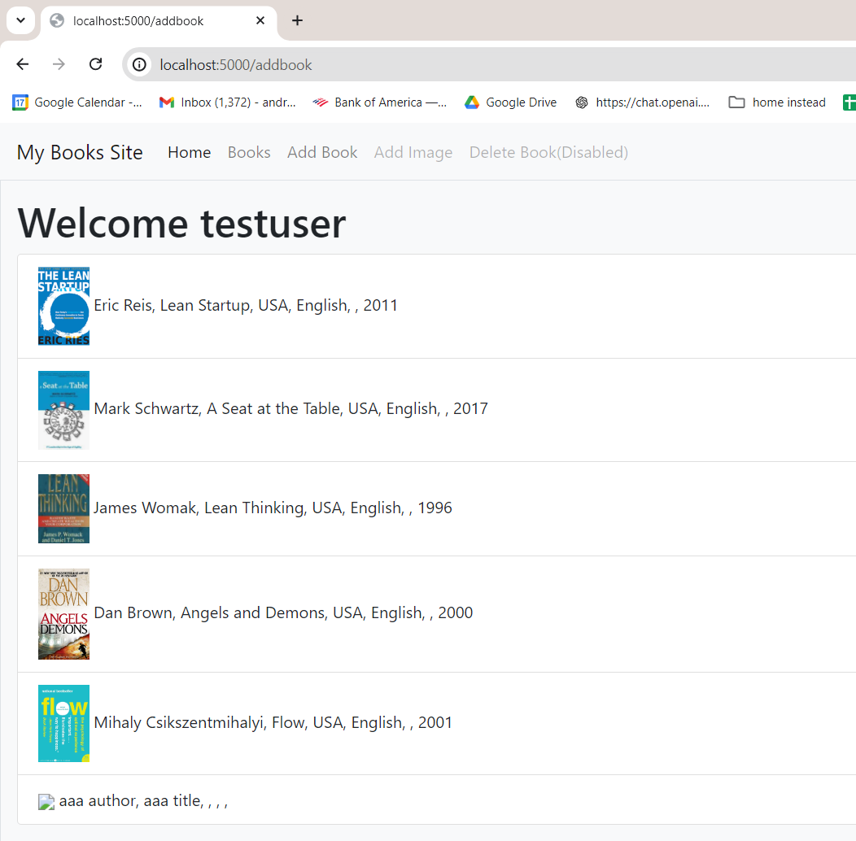

1. Provide a screenshot to show that you successfully logged in as a reader.

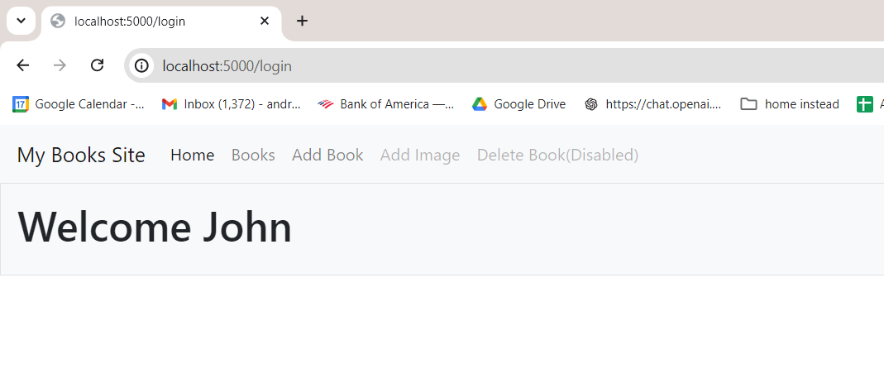

1. Provide a screenshot of the error message to show that you can’t add a new book to your website using an account with only reader privileges.

